Template in Letter Page Size

J. Clerk Maxwell#1, Charles Darwin$, Michael Faraday*^2, André M. Ampère#3

#My Lab, My University, USA

$Gollum World, New Zealand

*Gollum World, Australia

^My Research, Australia

{1elec666, 3elec123}@my-uni.edu, 2michael@mr.com.au

***Abstract*—Limit your abstract to one paragraph and keep it short. In the Keywords section, enter keywords or phrases in alphabetical order, separated by commas. Using the IEEE Thesaurus can help you find the best standardized keywords to fit your paper. Use the thesaurus access request form for free access to the IEEE Thesaurus [1] at https://www.ieee.org/publica  
tions/services/thesaurus.html.**

***Keywords*—ceramics, coaxial resonators, delay filters, power amplifiers.**

1. Introduction

Not all IEEE conferences use the same template. For your paper to be published in the conference proceedings, you must use this document as both an instruction set and as a template into which you can type your own text. If your paper does not conform to the required format, you will be asked to fix it.

Papers which have been reviewed and accepted by the committee may still have format problems identified later by the publisher. All format problems which the publisher has requested you to fix must be fixed before it can be published in the conference proceedings.

***Do not reuse your past papers as a template, even if your past papers conformed to the required format. To prepare your paper for submission, always download a fresh copy of this template from the conference website and read the format instructions in this template before you use it for your paper.***

IEEE PDF eXpress checks your paper for IEEE Xplore compatibility. IEEE PDF eXpress does not check for format compliance. When your paper in PDF passes the checking by IEEE PDF eXpress, it does not mean that your paper conforms to the format requirements specified by the conference. You must check your paper for format compliance.

Conversion to PDF may cause problems in the resulting PDF or expose problems in your source document. Before submitting your final paper in PDF, check that the format in your paper in PDF conforms to this template. Specifically, check the appearance of the title and author block, the appearance of section headings, document margins, column width, column spacing, and other features such as section numbers, figure numbers, table numbers and equation numbers. In summary, you must proofread your final paper in PDF before submission.

1. Page Limit and Page Layout
2. *Page Limit*

The page limit is 4 pages. You must not reduce margins or font-sizes or spacing to meet the page limit. You must not change the required formats to meet the page limit.

In summary, you must follow the formats as shown in this template (eg acknowledgments must be formatted as a separate section and not as a paragraph, single author block centered to the page must be used instead of multiple author blocks). You will be asked to fix these format problems if any such format deviations are detected.

An easy way to comply with the conference paper format requirements is to use this document as a template and simply type your text into it.

1. *Page Layout*

Your paper must use a page size corresponding to US Letter which is 8.5" (215.9mm) wide and 11" (279.4mm) long.

The margins must be set as follows:

* top = 0.75" (19mm)
* bottom = 1" (25.4mm)
* left = right = 0.63" (16mm).

Your paper must be in two column format with a space of 0.25" (6.3mm) between columns.

1. Page Style
2. *Text Font of Entire Document*

The entire document must be mainly in Times New Roman or Times font. Other fonts (eg Symbol font), if needed for special purposes, may be used sparingly. Type 3 fonts must not be used.

Required font sizes are shown in Table 1.

1. *Title*

Title must be in 18pt regular font style (ie not bold and not italic). Title must be in single-column format and must be centered to the page.

Every word in a title must be capitalized except for short minor words such as “a”, “an”, “and”, “as”, “at”, “by”, “for”, “from”, “if”, “in”, “into”, “on”, “or”, “of”, “the”, “to”, and “with”.

Table 1. Font sizes for papers. Table caption with more than one line must be justified. Table caption with just one line must be centered.

|  |  |  |  |
| --- | --- | --- | --- |
| **Font Size** | **Appearance (in Times New Roman or Times)** | | |
| regular | **bold** | *italic* |
| 8 | table caption,  figure caption,  figure label,  reference item |  | reference item (partial) |
| 9 | cell in a table | abstract,  keywords | also in bold:  abstract section heading,  keywords section heading |
| 10 | level-1 heading,  paragraph,  equation |  | level-2 heading,  level-3 heading |
| 12 | author name,  author affiliation,  email address |  |  |
| 18 | title |  |  |

1. *Author Details*

The details of all authors must be shown in a single author block. The author block consists of the author list, all author affiliations referred to in the author list and author email addresses. The author block must be in single-column format and must be centered to the page.

1. *Author List*

The author list must consist of author names separated by a comma followed by one space without the word “and”. Author details must not show any professional title (eg Managing Director), any academic title (eg Dr.) or any membership of any professional organization (eg Senior Member IEEE).

Do not split an author name into two lines, ie an author name must appear entirely on the same line. Use a soft line break to force the entire author name onto next line if the author name splits into two lines.

To avoid confusion, the family name must be written as the last part of each author name (eg John A.K. Smith) and must not be shown in all uppercase. To avoid incorrect author name indexing by digital libraries, an author with more than one family name should consider hyphenating the multiple family names (eg Francisco Santos-Leal).

1. *Author Affiliations*

Affiliations must be shown in the order they are referred to in the author list.

Each affiliation must include the name of the company and the name of the country where the author is based (eg Causal Productions, Australia).

Each different affiliation must be on a separate line. Same company name with a different location must be treated as if it were a different affiliation.

Do not show physical address, partial physical address, phone number or fax number.

1. *Author Email Addresses*

Email address must be shown for the corresponding author. Email addresses for all other authors are optional.

1. *Affiliation/Email-Address Marker*

All affiliation markers must consist of a single unique character in superscript style. Affiliation markers used in this template are: “#”, “$”, “*”, “^”. A unique affiliation marker must be used for each different affiliation. If all authors have the same affiliation, there is no need to use affiliation marker.

All email address markers must consist of a single unique character in superscript style. Email address markers used in this template are: “1”, “2”, “3”. A unique email address marker must be used for each different author who shows an email address on the manuscript. Authors who do not show an email address must not have an email address marker after their name. If all email addresses are self-identifiable, there is no need to use email address markers.

1. *Section Headings*

No more than 3 levels of headings should be used. All headings must be in 10pt font. Every word in a heading must be capitalized except for short minor words as listed in Section III.B.

A section heading must not be left as an orphan at the end of a column. Use a column break to force the section heading onto the next column.

1. *Level-1 Heading*

A level-1 heading must be in small caps, centered and numbered using uppercase Roman numerals (eg heading of section I). The only exception is in the case of the acknowledgment section heading and the references section heading: these two level-1 section headings must not have section numbers.

1. *Level-2 Heading*

A level-2 heading must be italic, justified and numbered using an uppercase alphabetic letter followed by a period (eg heading of section III.D).

1. *Level-3 Heading*

A level-3 heading must be italic, justified and numbered using Arabic numerals followed by a right parenthesis (eg heading of section III.D.3).

1. *Paragraphs*

All paragraphs must have an indentation of 0.2" (5.1mm) on the first line. There must not be any spacing before and after a paragraph. All paragraphs must be justified.

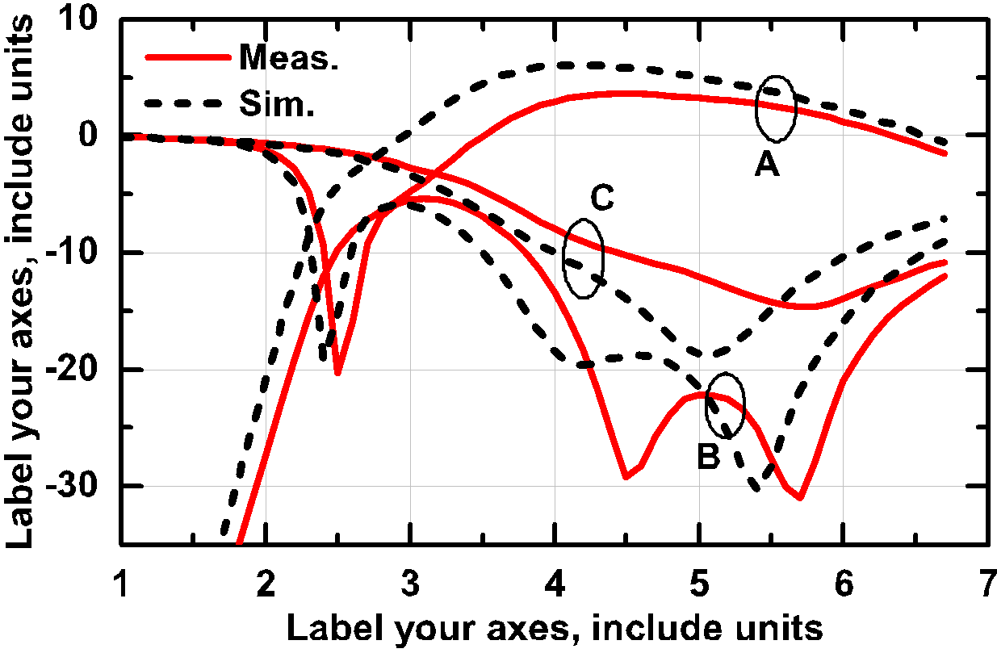

Fig. 1. A sample line graph using colors which contrast well both on screen and on a black-and-white hardcopy. Figure caption with more than one line must be justified. Figure caption with only one line must be centered.

1. *Figures and Tables*

Figures and tables must be centered in the column. Large figures and tables may span across both columns. Any figure or table that takes up more than one column width must be placed either at the top or at the bottom of the page, as shown in Fig. 3 and Table 2.

Graphics may be grayscale or full color. All colors will be retained in the proceedings. Use only colors which contrast well both on screen and on black-and-white hardcopy, as shown in Fig. 1, with the black and red curves. Note that simulation and measurement are clearly distinguished through different colors and different line styles. Also, the axis fonts and any labels are not smaller than the figure caption font. Do not attempt to overload the plot with too many separate curves; each curve should be distinguishable.

Fig. 2a shows an example of a low-resolution image which would not be acceptable, whereas Fig. 2b shows an example of an image with adequate resolution. Check that the resolution is adequate to reveal the important detail in the figure.

Check all figures in your paper both on screen and on a black-and-white hardcopy. When you check your paper on a black-and-white hardcopy, ensure that:

* the colors used in each figure contrast well
* the image used in each figure is clear
* all text labels in each figure are legible.

1. *Figure Numbers and Table Numbers*

Figures and tables must be numbered using Arabic numerals (eg 1, 2, etc).

Figures have their own sequence of numbers starting from Fig. 1. Figures must be numbered consecutively in the order they appear in your paper.

Tables have their own sequence of numbers starting from Table 1. Tables must be numbered consecutively in the order they appear in your paper.

1. *Figure Captions and Table Captions*

Captions must be in 8pt regular font. A single-line caption must be centered (eg Fig. 2, Table 2) whereas a multi-line caption must be justified (eg Fig. 1, Fig. 3, Table 1).

Caption width must be the same as the column width or the width between the left and the right margins.

A figure caption must be placed below the associated figure whereas a table caption must be placed above the associated table.

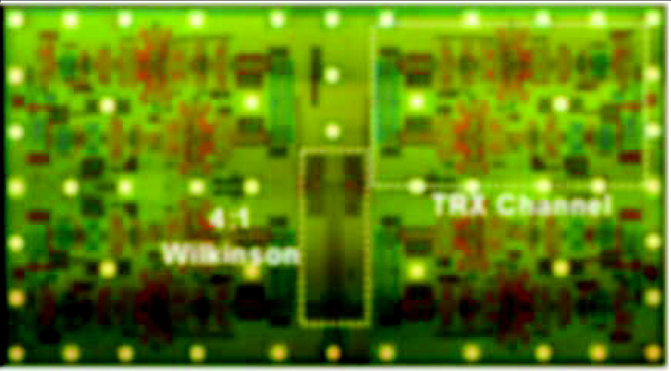

(a)

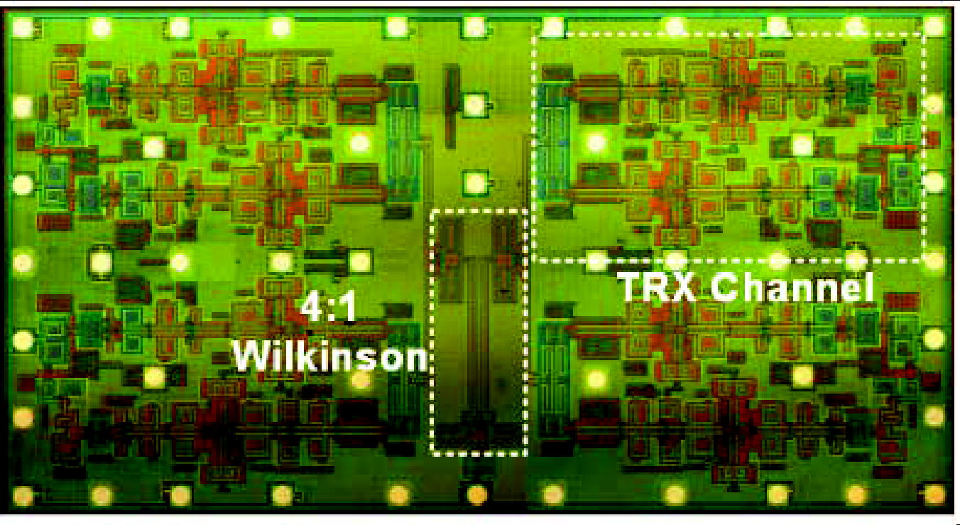

(b)

Fig. 2. Image resolution: (a) unacceptable; (b) acceptable.

A caption must be kept together with its associated figure or table, ie they must not be separated into different columns or onto different pages.

When a figure contains more than one component (eg   
Fig. 2), each component must be identified using component label eg (a), (b) etc. Each component label must not contain any description. Description of each component must be placed in the figure caption, as shown in Fig. 2 caption.

1. *Page Numbers, Headers and Footers*

Page numbers, headers and footers must not be used.

1. *Links and Bookmarks*

During the processing of papers for publication, all hypertext links and section bookmarks will be removed from papers and the affected text will be changed to black color. If you need to refer to an Internet email address or URL in your paper, you must write the address or URL fully in your text in regular font style and black color.

1. *Equations*

Equations should be right justified and numbered sequentially. Place the equation number to the right of the equation within a parenthesis. An example would be

(1)

or

(2)

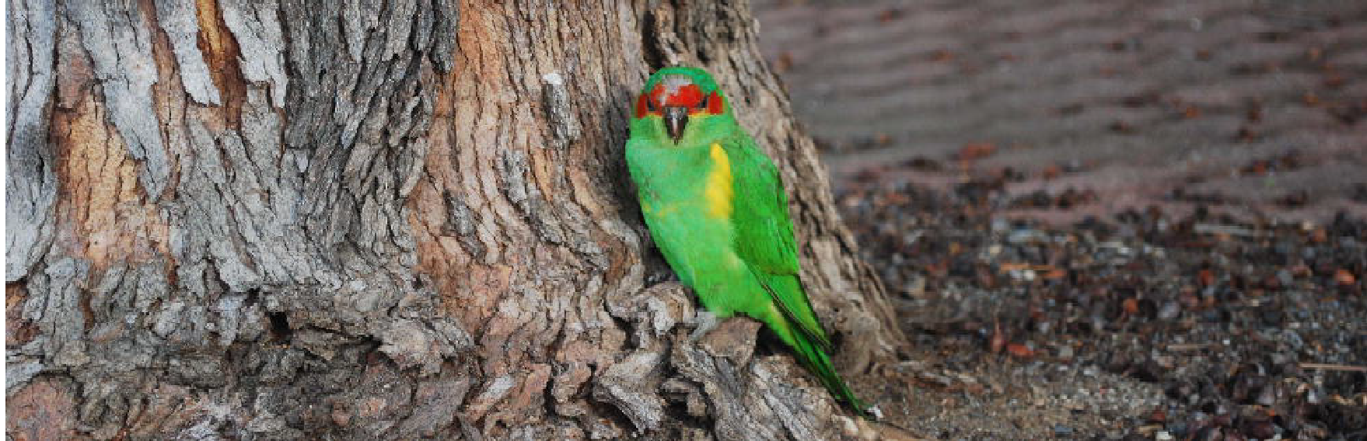

Fig. 3. A figure which spans two columns must be placed either at the top of a page or at the bottom of a page. Figure caption with more than one line must be justified. Figure caption with only one line must be centered.

Table 2. Main predefined styles in WORD. Table which spans 2 columns must be placed either at top of a page or at bottom of a page.

|  |  |
| --- | --- |
| **Style Name** | **To Format …** |
| RFIC Title | title |
| RFIC Author Block | author name, author affiliation, author email address |
| RFIC Marker | affiliation markers and email address markers in the author block |
| RFIC Abstract/Keywords Heading | abstract section heading, keywords section heading |
| RFIC Abstract/Keywords | abstract, keywords |
| RFIC Heading 1 | level-1 heading |
| RFIC Heading 2 | level-2 heading |
| RFIC Heading 3 | level-3 heading |
| RFIC Paragraph | paragraph |
| RFIC Bullet | bullet item |
| RFIC Equation | equation |
| RFIC Figure | figure to be centered |
| RFIC Figure Label | label placed below a component of a figure, eg (a) in Fig.2 |
| RFIC Caption Single-Line | figure or table caption containing one line |
| RFIC Caption Multi-Lines | figure or table caption containing more than one line |
| RFIC Acknowledgment Heading | acknowledgment section heading |
| RFIC Reference Heading | reference section heading |
| RFIC Reference Item | reference item |
| RFIC Italics | part of a reference item in italics |

1. *References*

The heading of the References section must not be numbered. All reference items must be in 8pt font. Number the reference items consecutively in square brackets (eg [1]).

When referring to a reference item, simply use the reference number, as in [2]. Do not use “Ref. [3]” or “Reference [3]” except at the beginning of a sentence, eg “Reference [3] shows …”. Multiple references are each numbered with separate brackets (eg [2], [3], [4]–[6]).

Examples of reference items of different categories shown in the References section include the following:

* example of a book in [2]
* example of a book in a series in [3]
* example of a journal article in [4]
* example of a conference paper in [5]
* example of a patent in [6]
* example of a website in [7]
* example of a web page in [8]
* example of a databook as a manual in [9]
* example of a datasheet in [10]
* example of a master’s thesis in [11]
* example of a technical report in [12]
* example of a standard in [13].

1. *Balancing Columns on a Page*

There is no requirement to balance both columns on any page including the last page, ie both columns are not required to be vertically aligned at the bottom. Do not change the vertical spacing to align the bottoms of both columns.

1. Review Submission vs. Final Submission

For review submission, in addition to other requirements, the ***RFIC double-blind reviewing policy requires that all author details and the acknowledgment section be hidden.*** For final submission, you must ensure that all text which has been hidden for review submission is unhidden. Section V and section VI provide hints on how to hide and unhide information in LaTeX and WORD respectively.

1. Important Information for LaTeX Users Only
2. *Information to Hide for Review Submission*

To hide text for blind review submission, please ensure that the following two lines in the .tex file appear uncommented and commented as shown below:

\RFICthispaperforblindreview

…

% \RFICthispaperforfinalpublication

1. *Information to Unhide for Final Submission*

For final submission, you must ensure that all text which has been hidden for blind review submission is visible by commenting the following two lines as shown:

% \RFICthispaperforblindreview

…

\RFICthispaperforfinalpublication

1. *All Other Must-Reads*

There are important differences between the IEEE format and the RFIC format, so you must use all files provided in the RFIC LaTeX template.

If the appearance is different from what is shown in this template, then the cause may be the use of conflicting style files in your .tex file (eg latex8.sty). You must remove all such conflicting style files.

For the table caption to appear above the table, you must place the table caption at the start of the table definition and before the table cells in your .tex file.

Authors must use the \raggedbottom option (as used in this template file) to avoid LaTeX inserting inconsistent and sometimes large spacing around section headings, around captions and around paragraphs.

You must follow the formats as shown in this template. You must not use alternative styles which are not used in this template (eg two-author block).

1. Important Information for WORD Users Only
2. *Information to Hide for Review Submission*

To hide text for blind review submission, select the text to be hidden, left click to select the “Font” panel, and then check “Hidden” under the heading “Effects”. ***To keep the page layout unchanged, for each hidden line, you must insert one blank line using the same style as that of the hidden text.***

1. *Information to Unhide for Final Submission*

For final submission, you must ensure that all text which has been hidden for blind review submission is unhidden. Simply select the entire WORD file, left click to select the “Font” panel, and then uncheck “Hidden” under the heading “Effects”. Remove all blank lines you have inserted as placeholders for the hidden text.

1. *All Other Must-Reads*

You must use the appropriate styles in Table 2 to format all parts of your paper. The styles in Table 2 have already taken into account the required vertical and horizontal spacing so there is no need to manually insert any spacing.

To format using a style name, open the “Styles” task pane under “Home”, select the text to be formatted, then select an appropriate style in the “Styles” task pane.

When the heading styles in Table 2 are used (eg “RFIC Heading 1” style), section numbers are no longer required to be typed in because they will be automatically numbered by WORD. Similarly, reference items will be automatically numbered by WORD when the “RFIC Reference Item” style is used.

Capitalize all section headings and then format them using an appropriate style from Table 2.

All level-1 section headings must be in small caps and must not be in all uppercase. There is a difference between small caps and all uppercase. Google the difference between these two so that you understand what small caps is.

After changing from single column format to two column format (eg after Table 2), always make sure that both the column width and the column spacing are the same as specified in the last paragraph of section II.B.

If your WORD document contains equations, you must not save your WORD document from “.docx” to “.doc” because when doing so, WORD will convert all equations to images of unacceptably low resolution.

WORD tables must not be used to house equations or references.

WORD creates text boxes around the relevant objects when the WORD commands such as “group”, “insert caption” are used. Text boxes must not be used with captions because it is difficult to set the same caption width for all captions inside text boxes. Simply type the caption below the figure or above the table and then format the caption using an appropriate style from Table 2.

To create a new line without breaking the paragraph, always use a soft line break by pressing the “Shift” key and the “Enter” key together.

To show or hide paragraph marks and hidden formatting symbols, press the “Control” key, the “Shift” key and the “8” key together to turn the toggle on or off. If the toggle is on, you should be able to see all control and hidden characters in your WORD file.

1. Conclusion

RFIC offers US Letter templates for LaTeX and WORD. The version of this template is V5. The format of this template was adapted by Causal Productions mainly from the IEEE LaTeX class file. There are important differences between the IEEE format and the RFIC format, so RFIC authors must use only the latest version of the RFIC templates.

Acknowledgment

The headings of the Acknowledgment section and the References section must not be numbered.

Causal Productions wishes to acknowledge Michael Shell and other contributors for developing and maintaining the IEEE LaTeX class file used in the preparation of this template. To see the list of contributors, please refer to the top of file IEEETran.cls in the IEEE LaTeX distribution.

References

1. (2023) IEEE Thesaurus. [Online]. Available: https://www.ieee.org/  
   publications/services/thesaurus.html
2. S. M. Metev and V. P. Veiko, *Laser Assisted Microtechnology*, 2nd ed., R. M. Osgood, Jr., Ed. Berlin, Germany: Springer-Verlag, 1998.
3. J. Breckling, Ed., *The Analysis of Directional Time Series: Applications to Wind Speed and Direction*, ser. Lecture Notes in Statistics. Berlin, Germany: Springer, 1989, vol. 61.
4. S. Zhang, C. Zhu, J. K. O. Sin, and P. K. T. Mok, “A novel ultrathin elevated channel low-temperature poly-Si TFT,” *IEEE Electron Device Lett.*, vol. 20, pp. 569–571, Nov. 1999.
5. M. Wegmuller, J. P. von der Weid, P. Oberson, and N. Gisin, “High resolution fiber distributed measurements with coherent OFDR,” in *Proc. ECOC’00*, 2000, paper 11.3.4, p. 109.
6. R. E. Sorace, V. S. Reinhardt, and S. A. Vaughn, “High-speed digital-to-RF converter,” U.S. Patent 5 668 842, Sep. 16, 1997.
7. (2015) The IEEE website. [Online]. Available: https://www.ieee.org/
8. M. Shell. (2015) IEEEtran webpage on CTAN. [Online]. Available: https://www.ctan.org/pkg/ieeetran
9. *FLEXChip Signal Processor (MC68175/D)*, Motorola, 1996.
10. “*PDCA12-70 Data Sheet*,” Opto Speed SA, Mezzovico, Switzerland.
11. A. Karnik, “Performance of TCP congestion control with rate feedback: TCP/ABR and rate adaptive TCP/IP,” M. Eng. thesis, Indian Institute of Science, Bangalore, India, Jan. 1999.
12. J. Padhye, V. Firoiu, and D. Towsley, “A stochastic model of TCP Reno congestion avoidance and control,” Univ. of Massachusetts, Amherst, MA, CMPSCI Tech. Rep. 99-02, 1999.
13. *Wireless LAN Medium Access Control (MAC) and Physical Layer (PHY) Specification*, IEEE Std. 802.11, 1997.